Dear Parents,

Thank you for your patience and support. Please take a deep breath and read the entire message. My goal is to help you feel comfortable and be here to support you. I have complete confidence in our ability to work together to make this time a success for your child.

Thank you for picking up the additional materials for your child. Don’t be nervous, there’s more than a week’s worth of work in the event the school closure is extended. You should have picked up the following items today…

*chapter 10 math book

*writing journal

*Student Workbook – Handwriting Book

*inside the folder –

-your child’s Tiger ID and password (notecard)

-4 Social Studies magazines

-2 stapled Science packets (handwashing & plants)

-CVC packet (CVC = consonant-vowel-consonant)

-ELA packet (I tried to put these in order)

-3 decodable books

For this week, you’ll need the first packet of materials (in the mailing envelope) and the Social Studies magazine, *Being A Good Citizen*.

Below you will find the assignments for the week. I have it broken down by day, but please make it work for your child and you. Most of us are now working from home and juggling more responsibilities than ever. My recommendation is that you try to have your child read and write (even if it’s a list of groceries) every day.

I’ve also added some extra practice and enrichment options if you are interested.

Kindergarten Remote Learning Plan

March 23 – March 27

*Each week, we’ll have ELA and Math. We’ll rotate weekly between Science and Social Socials.

**Monday, March 23**

*Follow FID menu (Our special today is recess, so get some exercise, play a game, choose something to do that

makes you happy. ☺

**Tuesday, March 24**

*Follow FID menu (Our special today is Library, choose something from the Library section)

**Going forward for specials area classes, please go to the special area teacher’s webpage and look under FID for what your child is to do that day.

*Wednesday – Art – Mrs. Knapp

*Thursday – Music – Mrs. (Samantha) Smith

*Friday – P.E. – Mr. Boronyak

**Wednesday, March 25**

*Math – lesson 6.1 – pages 311-313, 315-316

*Social Studies – **Being a Good Citizen** magazine – read pages 2-7

**Thursday, March 26**

*ELA – Digraph ***sh*** - A digraph is the combination of two letters that make one sound

(feel free to have your child watch these short videos)

<https://www.youtube.com/watch?v=V__JP2QFLws>

<https://www.youtube.com/watch?v=HfMtsRVZWfE>

1. practice making the */sh/*sound
2. *sh* digraph worksheet (2-sided)

3. *sh seashell* worksheet

*use this worksheet to interview/ask 2 or more family members to name a word that begins with (or

contains) *sh*  - write the words on the lines, practice reading the words

*Social Studies – **Being a Good Citizen** magazine – read pages 8-13

**Friday, March 27**

*Math – lesson 6.2 – pages 317-319, 321-322

When using the 10-frame, have your child color the total number of boxes, cross out the number being subtracted, then write the number sentence.

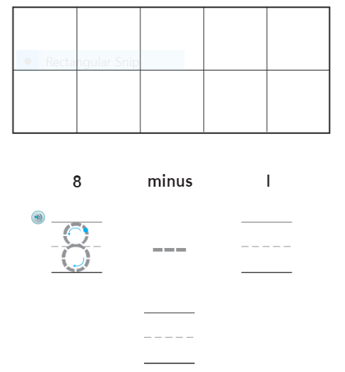

*Social Studies – **Being a Good Citizen** magazine – read pages 14-19

**Extra Practice and Enrichment Options**

*ELA – Raz Kids <https://www.raz-kids.com/>

Choose 2+ pages to complete in the Handwriting Workbook

*Math – practice counting to 100 by 1s, 2s, 5s, and 10s

Complete pages 308-310 in chapter 6 math book

*Social Studies – choose an activity from page 18 in Being a Good Citizen to complete

You should have received the email below from NA’s technology department. Please reach out to them if you have questions about logging in, please contact the Service Desk.

For your Kindergarten student to be able to check into school for remote learning starting on Monday, March 23 you will need to know your child’s TigerID which is displayed below along with several other links you may find helpful.  **The check-in app will be active beginning Monday, March 23.** [Visit our website for directions.](https://nam02.safelinks.protection.outlook.com/?url=https%3A%2F%2Fnasd.school%2FStudentRemoteCheckIn&data=02%7C01%7CDKing%40northallegheny.org%7Cefd6651b80334de81dda08d7cde2f32c%7C030d132b2d0c4ceb9a5f21a90cb294af%7C0%7C0%7C637204246941366272&sdata=7mLCAgtyJYb5efKs%2BvNabiJ0B2agrFNdZ7FmTCN9lEs%3D&reserved=0)

If you have any questions about the check in process, our Service Desk will be staffed early Monday morning. You may contact the Service Desk at ☎️ 412-369-5849 or 📧  [servicedesk@northallegheny.org](mailto:servicedesk@northallegheny.org).

Regards,

Richard Platts, CETL

Director of Technology and Innovation

Thank you again for your patience and support. I’m here to help should you have any questions or concerns. We’ll get through this together.

Stay healthy and safe!

Dena